1. Write a program in assembly language to take a single-digit integer from the user
and print it on the screen.
Code
ORG 100h ; Origin, to specify that the program starts at 100h (COM file format)
; Display message "Enter a digit: "
MOV DX, OFFSET msg_input ; Load the address of the message
MOV AH, 09h ; Function 09h of INT 21h is used to display a string
INT 21h ; Call DOS interrupt to print the message

; Read a single character from the user
MOV AH, 01h ; Function 01h of INT 21h is used to read a character
INT 21h ; Call DOS interrupt to get the character
MOV BL, AL ; Store the input character in AL

; Check if the character is a digit (0-9)
CMP BL, '0' ; Compare AL with '0'
JL NotDigit ; If the input is less than '0', it is not a digit
CMP BL, '9' ; Compare AL with '9'
JG NotDigit ; If the input is greater than '9', it is not a digit

; Print the message "The entered digit is: " on a new line
MOV DX, OFFSET msg_output ; Load the address of the output message
MOV AH, 09h ; Function 09h of INT 21h is used to display a string
INT 21h ; Call DOS interrupt to print the output message

; Print the entered digit
MOV DL, BL ; Move the entered digit to DL
MOV AH, 02h ; Function 02h of INT 21h is used to print a single character
INT 21h ; Call DOS interrupt to print the character
JMP EndProgram ; Jump to the end of the program

NotDigit:
; If the input is not a digit, display an error message on a new line
MOV DX, OFFSET msg_error ; Load the address of the error message
MOV AH, 09h ; Function 09h of INT 21h is used to display a string
INT 21h ; Call DOS interrupt to print the error message

EndProgram:
; Terminate the program
MOV AH, 4Ch ; Function 4Ch of INT 21h terminates the program
INT 21h ; Call DOS interrupt to exit

msg_input DB 'Enter a digit: $'
msg_output DB 0Dh, 0Ah, 'The entered digit is: $' ; Output message on a new line
msg_error DB 0Dh, 0Ah, 'Error: Not a digit! $' ; Error message on a new line

END

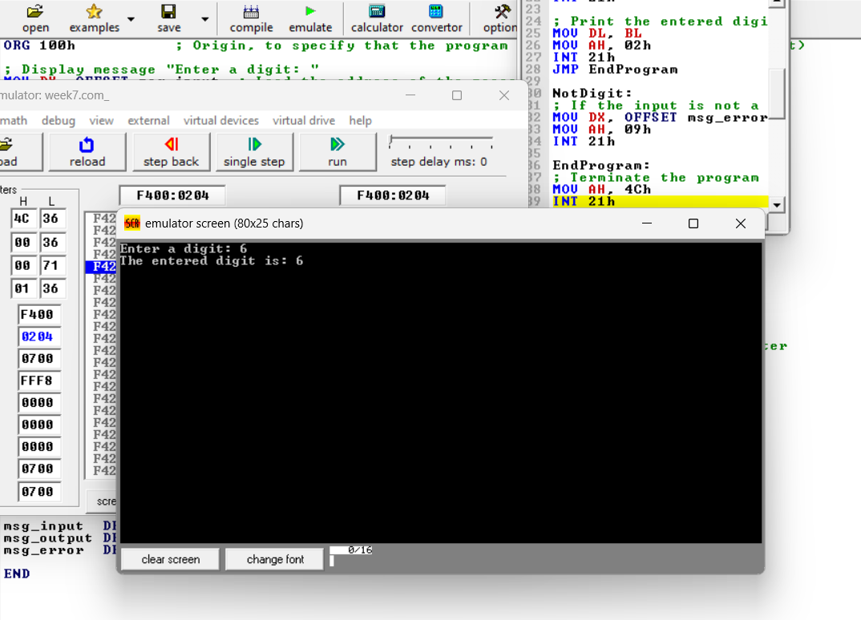

2. Write a program in assembly language to take two single-digit integers from the
user and print the result of subtraction on the screen.
ORG 100h ; Origin, to specify that the program starts at 100h (COM file format)

; Display message "Enter the first digit: "
MOV DX, OFFSET msg_input1 ; Load the address of the first input message
MOV AH, 09h ; Function 09h of INT 21h is used to display a string
INT 21h ; Call DOS interrupt to print the message

; Read the first digit from the user
MOV AH, 01h ; Function 01h of INT 21h is used to read a character
INT 21h ; Call DOS interrupt to get the character
SUB AL, '0' ; Convert ASCII to integer by subtracting '0'
MOV BL, AL ; Store the first digit in BL

; Display message "Enter the second digit: "
MOV DX, OFFSET msg_input2 ; Load the address of the second input message
MOV AH, 09h ; Function 09h of INT 21h is used to display a string
INT 21h ; Call DOS interrupt to print the message

; Read the second digit from the user
MOV AH, 01h ; Function 01h of INT 21h is used to read a character
INT 21h ; Call DOS interrupt to get the character
SUB AL, '0' ; Convert ASCII to integer by subtracting '0'
MOV BH, AL ; Store the second digit in BH

; Perform subtraction: BL - BH
SUB BL, BH ; Subtract the second digit (BH) from the first (BL)

; Print the message "The result of subtraction is: "
MOV DX, OFFSET msg_output ; Load the address of the output message
MOV AH, 09h ; Function 09h of INT 21h is used to display a string
INT 21h ; Call DOS interrupt to print the output message

; Check if the result is negative
CMP BL, 0 ; Compare the result with 0
JGE PositiveResult ; Jump to PositiveResult if the result is non-negative

; Negative result, print the negative sign
MOV DL, '-' ; Load the ASCII value for the negative sign '-'
MOV AH, 02h ; Function 02h of INT 21h is used to print a single character
INT 21h ; Call DOS interrupt to print the negative sign

; Convert the negative result to positive for display
NEG BL ; Negate the value to convert it to a positive

PositiveResult:
; Convert the result to ASCII
ADD BL, '0' ; Convert the result back to ASCII

; Print the result of subtraction
MOV DL, BL ; Move the result to DL
MOV AH, 02h ; Function 02h of INT 21h is used to print a single character
INT 21h ; Call DOS interrupt to print the character

EndProgram:
; Terminate the program
MOV AH, 4Ch ; Function 4Ch of INT 21h terminates the program
INT 21h ; Call DOS interrupt to exit

; Data Section
msg_input1 DB 'Enter the first digit: $' ; Input prompt for the first digit
msg_input2 DB 0Dh, 0Ah, 'Enter the second digit: $' ; Input prompt for the second digit
msg_output DB 0Dh, 0Ah, 'The result of subtraction is: $' ; Output message

END ; End of program